A. Homework 4          Zhou, Tiancong

B. XML in courier font, indented

<?xml version="1.0" standalone="no"?>  
<CATALOG xmlns:xsi="[http://www.w3.org/2001/XMLSchema-instance](http://www.w3.org/2001/XMLSchema-instance" \t "_blank)">  
  
   <CD id="C001">  
      <TITLE>Empire Burlesque</TITLE>  
      <ARTIST>Bob Dylan</ARTIST>  
      <COUNTRY>USA</COUNTRY>  
      <COMPANY>Columbia;</COMPANY>  
      <PRICE>10.90</PRICE>  
      <YEAR>1985</YEAR>  
   </CD>  
    <CD id="C002">  
      <TITLE>Hide your heart</TITLE>  
      <ARTIST>Bonnie Tyler</ARTIST>  
      <COUNTRY>UK</COUNTRY>  
      <COMPANY>CBS Records;</COMPANY>  
      <PRICE>9.90</PRICE>  
      <YEAR>1988</YEAR>  
   </CD>  
    <CD id="C003">  
      <TITLE>Greatest Hits</TITLE>  
      <ARTIST>Dolly Parton</ARTIST>  
      <COUNTRY>USA</COUNTRY>  
      <COMPANY>RCA;</COMPANY>  
      <PRICE>9.90</PRICE>  
      <YEAR>1982</YEAR>  
   </CD>  
    <CD id="C004">  
      <TITLE>Still got the blues</TITLE>  
      <ARTIST>Gary Moore</ARTIST>  
      <COUNTRY>UK</COUNTRY>  
      <COMPANY>Virgin records;</COMPANY>  
      <PRICE>10.20</PRICE>  
      <YEAR>1990</YEAR>  
   </CD>  
    <CD id="C005">  
      <TITLE>Eros</TITLE>  
      <ARTIST>Eros Ramazzotti</ARTIST>  
      <COUNTRY>EU</COUNTRY>  
      <COMPANY>BMG;</COMPANY>  
      <PRICE>9.90</PRICE>  
      <YEAR>1997</YEAR>  
   </CD>  
   <CD id="C006">  
      <TITLE>One night only</TITLE>  
      <ARTIST>Bee Gees</ARTIST>  
      <COUNTRY>UK</COUNTRY>  
      <COMPANY>Polydor;</COMPANY>  
      <PRICE>10.90</PRICE>  
      <YEAR>1998</YEAR>  
   </CD>  
    <CD id="C007">  
      <TITLE>Sylvias Mother</TITLE>  
      <ARTIST>Dr.Hook</ARTIST>  
      <COUNTRY>UK</COUNTRY>  
      <COMPANY>CBS;</COMPANY>  
      <PRICE>8.10</PRICE>  
      <YEAR>1973</YEAR>  
   </CD>  
    <CD id="C008">  
      <TITLE>Maggie May</TITLE>  
      <ARTIST>Rod Stewart</ARTIST>  
      <COUNTRY>UK</COUNTRY>  
      <COMPANY>Pickwick;</COMPANY>  
      <PRICE>8.50</PRICE>  
      <YEAR>1990</YEAR>  
   </CD>  
    <CD id="C009">  
      <TITLE>Romanza</TITLE>  
      <ARTIST>Andrea Bocelli</ARTIST>  
      <COUNTRY>EU</COUNTRY>  
      <COMPANY>Polydor;</COMPANY>  
      <PRICE>10.80</PRICE>  
      <YEAR>1996</YEAR>  
   </CD>  
    <CD id="C0010"  
        similarTo="C0011 C0012 C0022 C0023">  
      <TITLE>When a man loves a woman</TITLE>  
      <ARTIST>Percy Sledge</ARTIST>  
      <COUNTRY>USA</COUNTRY>  
      <COMPANY>Atlantic;</COMPANY>  
      <PRICE>8.70</PRICE>  
      <YEAR>1987</YEAR>  
   </CD>  
    <CD id="C0011"  
        similarTo="C0010 C0012 C0022 C0023">  
      <TITLE>Black angel</TITLE>  
      <ARTIST>Savage Rose</ARTIST>  
      <COUNTRY>EU</COUNTRY>  
      <COMPANY>Columbia0;</COMPANY>  
      <PRICE>10.90</PRICE>  
      <YEAR>1995</YEAR>  
   </CD>  
    <CD id="C0012"  
        similarTo="C0010 C0011 C0022 C0023">  
      <TITLE>1999 Grammy Nominees</TITLE>  
      <ARTIST>Many</ARTIST>  
      <COUNTRY>USA</COUNTRY>  
      <COMPANY>Grammy;</COMPANY>  
      <PRICE>10.20</PRICE>  
      <YEAR>1999</YEAR>  
   </CD>  
    <CD id="C0013">  
      <TITLE>For the good times</TITLE>  
      <ARTIST>Kenny Rogers</ARTIST>  
      <COUNTRY>UK</COUNTRY>  
      <COMPANY>Mucik Master;</COMPANY>  
      <PRICE>8.70</PRICE>  
      <YEAR>1995</YEAR>  
   </CD>  
    <CD id="C0014">  
      <TITLE>Big Willie style</TITLE>  
      <ARTIST>Will Smith</ARTIST>  
      <COUNTRY>USA</COUNTRY>  
      <COMPANY>Columbia;</COMPANY>  
      <PRICE>9.90</PRICE>  
      <YEAR>1997</YEAR>  
   </CD>  
    <CD id="C0015">  
      <TITLE>Tupelo Honey</TITLE>  
      <ARTIST>Van Morrison</ARTIST>  
      <COUNTRY>UK</COUNTRY>  
      <COMPANY>Polydor;</COMPANY>  
      <PRICE>8.20</PRICE>  
      <YEAR>1971</YEAR>  
   </CD>  
    <CD id="C0016">  
      <TITLE>Soulsville</TITLE>  
      <ARTIST>Jorn Hoel</ARTIST>  
      <COUNTRY>Norway</COUNTRY>  
      <COMPANY>WEA;</COMPANY>  
      <PRICE>7.90</PRICE>  
      <YEAR>1996</YEAR>  
   </CD>  
    <CD id="C0017">  
      <TITLE>The very best of</TITLE>  
      <ARTIST>Cat Stevens</ARTIST>  
      <COUNTRY>UK</COUNTRY>  
      <COMPANY>Island;</COMPANY>  
      <PRICE>8.90</PRICE>  
      <YEAR>1990</YEAR>  
   </CD>  
    <CD id="C0018">  
      <TITLE>Stop</TITLE>  
      <ARTIST>Sam Brown</ARTIST>  
      <COUNTRY>UK</COUNTRY>  
      <COMPANY>A and M;</COMPANY>  
      <PRICE>8.90</PRICE>  
      <YEAR>1988</YEAR>  
   </CD>  
    <CD id="C0019">  
      <TITLE>Bridge of Spies</TITLE>  
      <ARTIST>T'Pau</ARTIST>  
      <COUNTRY>UK</COUNTRY>  
      <COMPANY>Siren;</COMPANY>  
      <PRICE>7.90</PRICE>  
      <YEAR>1987</YEAR>  
   </CD>  
    <CD id="C0020">  
      <TITLE>Private Dancer</TITLE>  
      <ARTIST>Tina Turner</ARTIST>  
      <COUNTRY>UK</COUNTRY>  
      <COMPANY>Capitol;</COMPANY>  
      <PRICE>8.90</PRICE>  
      <YEAR>1983</YEAR>  
   </CD>  
    <CD id="C0021">  
      <TITLE>Midt om natten</TITLE>  
      <ARTIST>Kim Larsen</ARTIST>  
      <COUNTRY>EU</COUNTRY>  
      <COMPANY>Medley;</COMPANY>  
      <PRICE>7.80</PRICE>  
      <YEAR>1983</YEAR>  
   </CD>  
    <CD id="C0022"  
        similarTo="C0010 C0011 C0012 C0023">  
      <TITLE>Pavarotti Gala Concert</TITLE>  
      <ARTIST>Luciano Pavarotti</ARTIST>  
      <COUNTRY>UK</COUNTRY>  
      <COMPANY>DECCA;</COMPANY>  
      <PRICE>9.90</PRICE>  
      <YEAR>1991</YEAR>  
   </CD>  
    <CD id="C0023"  
        similarTo="C0010 C0011 C0012 C0022">  
      <TITLE>The dock of the bay</TITLE>  
      <ARTIST>Otis Redding</ARTIST>  
      <COUNTRY>USA</COUNTRY>  
      <COMPANY>Atlantic;</COMPANY>  
      <PRICE>7.90</PRICE>  
      <YEAR>1987</YEAR>  
   </CD>  
    <CD id="C0024">  
      <TITLE>Picture book</TITLE>  
      <ARTIST>Simply Red</ARTIST>  
      <COUNTRY>EU</COUNTRY>  
      <COMPANY>Elektra;</COMPANY>  
      <PRICE>7.20</PRICE>  
      <YEAR>1985</YEAR>  
   </CD>  
    <CD id="C0025">  
      <TITLE>Red</TITLE>  
      <ARTIST>The Communards</ARTIST>  
      <COUNTRY>UK</COUNTRY>  
      <COMPANY>London;</COMPANY>  
      <PRICE>7.80</PRICE>  
      <YEAR>1987</YEAR>  
   </CD>  
    <CD id="C0026">  
      <TITLE>Unchain my heart</TITLE>  
      <ARTIST>Joe Cocker</ARTIST>  
      <COUNTRY>USA</COUNTRY>  
      <COMPANY>EMI;</COMPANY>  
      <PRICE>8.20</PRICE>  
      <YEAR>1987</YEAR>  
   </CD>  
    <CD id="C0027">  
      <TITLE>Doo - Wops &amp; Hooligans</TITLE>  
      <ARTIST>Bruno Mars</ARTIST>  
      <COUNTRY>USA</COUNTRY>  
      <COMPANY>Epic;</COMPANY>  
      <PRICE>9.90</PRICE>  
      <YEAR>2010</YEAR>  
   </CD>  
    <CD id="C0028">  
      <TITLE>We Sing, We Dance, We Steal Things </TITLE>  
      <ARTIST>Jason Mraz</ARTIST>  
      <COUNTRY>USA</COUNTRY>  
      <COMPANY>Atlantic;</COMPANY>  
      <PRICE>8.90</PRICE>  
      <YEAR>2008</YEAR>  
   </CD>  
    <CD id="C0029">  
      <TITLE>Little Voice</TITLE>  
      <ARTIST>Sara Bareilles</ARTIST>  
      <COUNTRY>USA</COUNTRY>  
      <COMPANY>Epic;</COMPANY>  
      <PRICE>7.90</PRICE>  
      <YEAR>2007</YEAR>  
   </CD>  
    <CD id="C0030">  
      <TITLE>Teenage Dream</TITLE>  
      <ARTIST>Katy Perry</ARTIST>  
      <COUNTRY>USA</COUNTRY>  
      <COMPANY>Capitol;</COMPANY>  
      <PRICE>13.90</PRICE>  
      <YEAR>2012</YEAR>  
      <TRACK>Teenage Dream</TRACK>  
      <TRACK>Last Friday Night</TRACK>  
      <TRACK>California Gurls</TRACK>  
      <TRACK>Firework </TRACK>  
      <TRACK>Peacock</TRACK>  
      <TRACK>Circle The Drain</TRACK>  
      <TRACK>The One That Got Away</TRACK>  
      <TRACK>E.T.</TRACK>  
      <TRACK>Who Am I Living For?</TRACK>  
      <TRACK>Pearl</TRACK>  
      <TRACK>Hummingbird Heartbeat</TRACK>  
      <TRACK>Not Like The Movies </TRACK>  
  
   </CD>  
    <CD id="C0031">  
      <TITLE>Continuum</TITLE>  
      <ARTIST>John Mayer</ARTIST>  
      <COUNTRY>USA</COUNTRY>  
      <COMPANY>Sony;</COMPANY>  
      <PRICE>6.90</PRICE>  
      <YEAR>2008</YEAR>  
      <TRACK> Waiting On the World To Change </TRACK>  
      <TRACK>I Don't Trust Myself (With Loving You) </TRACK>  
      <TRACK>Belief </TRACK>  
      <TRACK>Gravity</TRACK>  
      <TRACK>The Heart of Life</TRACK>  
      <TRACK>Vultures</TRACK>  
      <TRACK>Stop This Train</TRACK>  
      <TRACK>Slow Dancing In a Burning Room</TRACK>  
      <TRACK>Bold As Love</TRACK>  
      <TRACK>Dreaming With a Broken Heart</TRACK>  
      <TRACK>In Repair</TRACK>  
      <TRACK>I'm Gonna Find Another You</TRACK>  
      <TRACK>Say</TRACK>  
        
   </CD>  
</CATALOG>

C. PHP program

<?php

ini\_set('display\_errors',true);

echo"<h2>display xpath result</h2>";

#create a simplexml XML object from local file

$xml=simplexml\_load\_file("cdCatalog3.xml");

#create a variable to get the parameter in the url

$year=$\_GET["YEAR"];

#get the directory of what needs to be displayed

$cds= $xml->xpath("//CATALOG/CD[YEAR='$year']");

#print each item.

echo"The year is $year <br/>";

foreach ($cds as $cd){

echo "CD: {$cd->TITLE} <br/>";

}

echo"<h2>--end display</h2>";

?>

D. Screen shot of the browser showing the URL of your program and the data returned by the PHP

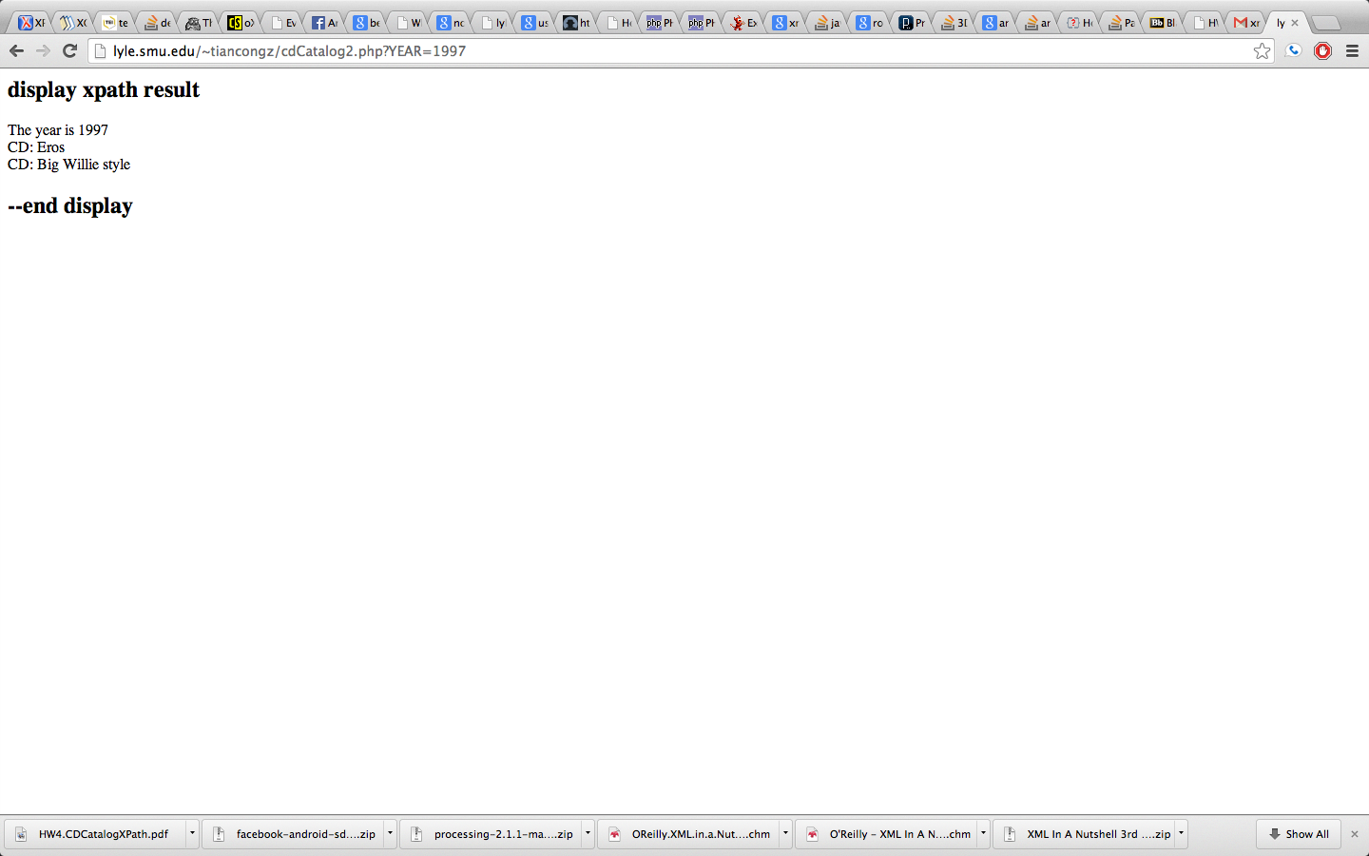

E. Links to your  XML, and PHP program that is available on a public server.

Link to XML: <http://lyle.smu.edu/~tiancongz/cdCatalog3.xml>

Link to PHP: [http://lyle.smu.edu/~tiancongz/cdCatalog2.php?YEAR=1997](http://lyle.smu.edu/~tiancongz/cdCatalog2.phpYEAR=1997)